LAB CYCLE -Part 2

ATHIRA JOJO
20MCA018

DATA HANDLING USING ‘Pandas’ and DATA VISUALIZATION USING ‘Seaborn’

Using the pandas function read_csv(), read the given ‘iris’ data set.

1. Use appropriate functions in pandas to displa
- Shape of the data set
- First 5 and last five rows of data set(head and tail)
- Size of dataset
- No:of samples available for each variety
- Description of the data set( use describe

CODE:
import numpy as np
import matplotlib.pyplot as plt
import seaborn as sns
import pandas as pd
col=['sepal_length','sepal_width','petal_length','petal_width','type']
iris=pd.read_csv("iris.csv",names=col)

print("Shape of the data set")
print("shape:",iris.shape)

print("First 5 and last five rows of data set(head and tail)")
print("First five rows")
print(iris.head())
print("last five rows")
print(iris.tail())

print("Size of dataset")
print("Size:",iris.size)

print("No of samples available for each type")
print(iris["type"].value_counts())

print(iris.describe())

OUTPUT:

Shape of the data set
shape: (151, 5)

First 5 and last five rows of data set(head and tail)
First five rows
sepal_length sepal_width petal_length petal_width type
0 sepal.length sepal.width petal.length petal.width variety
1 5.1 3.5 1.4 .2 Setosa
2 4.9 3 1.4 .2 Setosa
3 4.7 3.2 1.3 .2 Setosa
4 4.6 3.1 1.5 .2 Setosa
last five rows
sepal_length sepal_width petal_length petal_width type
146 6.7 3 5.2 2.3 Virginica
147 6.3 2.5 5 1.9 Virginica
148 6.5 3 5.2 2 Virginica
149 6.2 3.4 5.4 2.3 Virginica
150 5.9 3 5.1 1.8 Virginica

Size of dataset
Size: 755

No of samples available for each type
Setosa 50
Versicolor 50
Virginica 50
variety 1
Name: type, dtype: int64

sepal_length sepal_width petal_length petal_width type
count 151 151 151 151 151
unique 36 24 44 23 4
top 5 3 1.5 .2 Setosa
freq 10 26 13 29 50

2. Use pairplot() function to display pairwise relationships between attributes. Try different kind of plots {‘scatter’, ‘kde’, ‘hist’, ‘reg’} and different kind of markers

CODE:

matplotlib inline

iris = sns.load_dataset('iris')
sns.pairplot(iris)

sns.pairplot(iris,kind="scatter")

sns.pairplot(iris,kind="kde")

sns.pairplot(iris,kind="hist")

sns.pairplot(iris,kind="reg")

OUTPUT:

<seaborn.axisgrid.PairGrid at 0x7f0717f755b0>

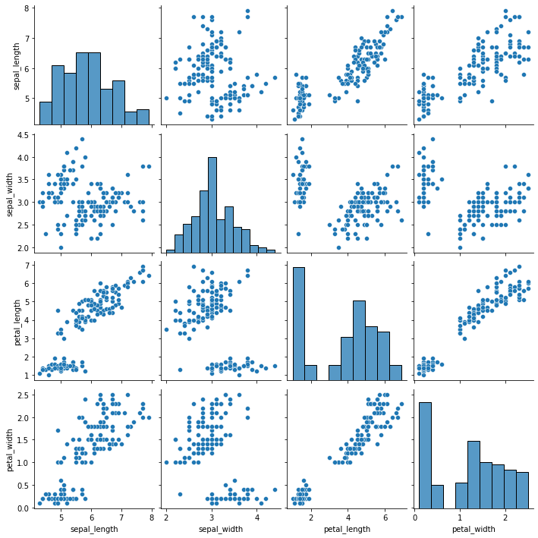

<seaborn.axisgrid.PairGrid at 0x7f071750c550>

<seaborn.axisgrid.PairGrid at 0x7f0717575ee0>

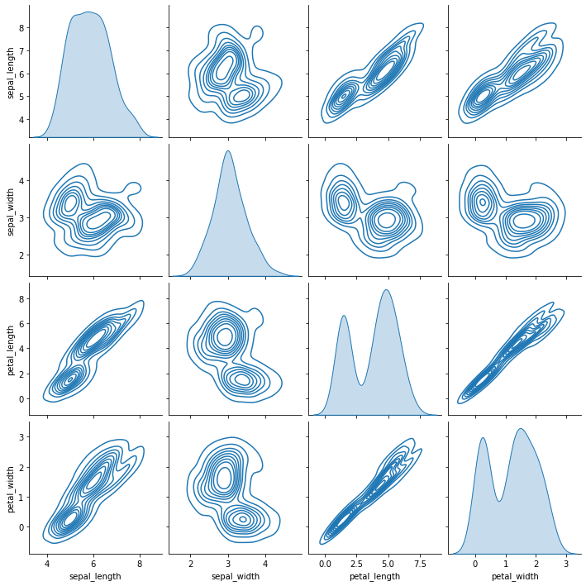

<seaborn.axisgrid.PairGrid at 0x7f0714187700>

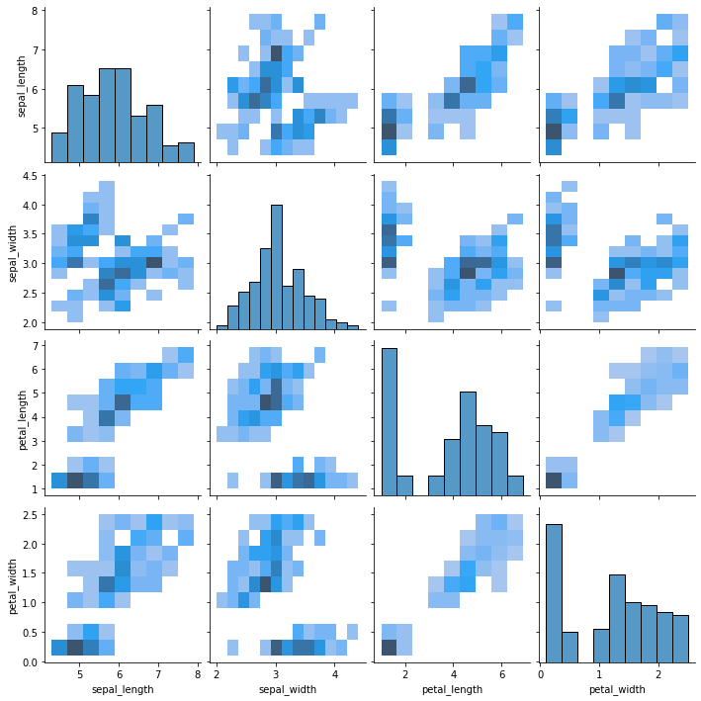

<seaborn.axisgrid.PairGrid at 0x7f070e8fd6a0>

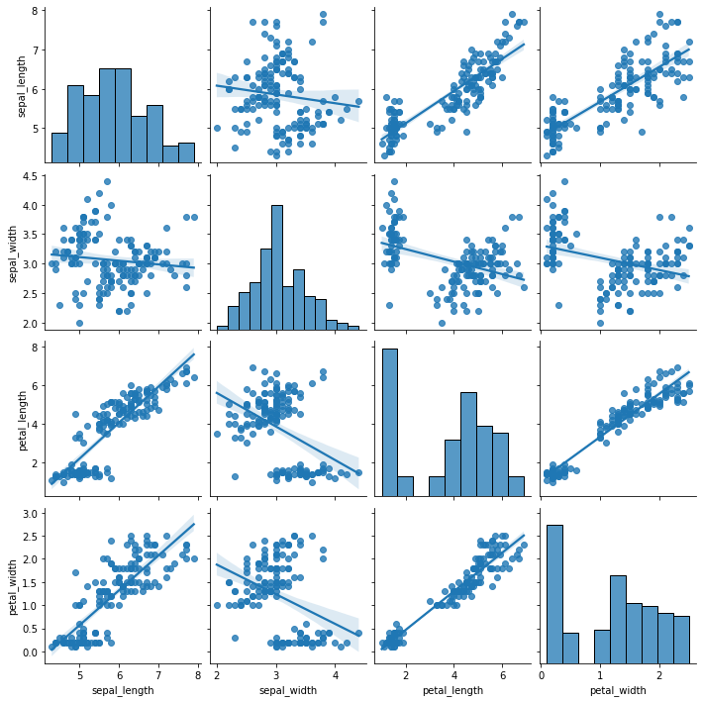

3.using the iris data set,get familiarize with functions:
1)displot()
2) histplot()
3) relplot()
CODE:

iris=sns.load_dataset('iris')
sns.displot(iris)

sns.histplot(iris)

sns.relplot(data=iris,kind="line")

plt.style.use("dark_background")
sns.displot(iris.sepal_length,bins=20,color="g")
plt.title("Distribution_sepal_length",fontsize=20,color="red")
plt.show()

plt.style.use("dark_background")
sns.displot(iris.sepal_width,bins=20,color="g")
plt.title("Distribution_sepal_width",fontsize=20,color="red")
plt.show()

OUTPUT:
